Name: Marwan Mohamed ZEin Amer
ID: 23011523
Assigment: Advanced DB TAsk 1

---

- Database Creation And Inserting Data
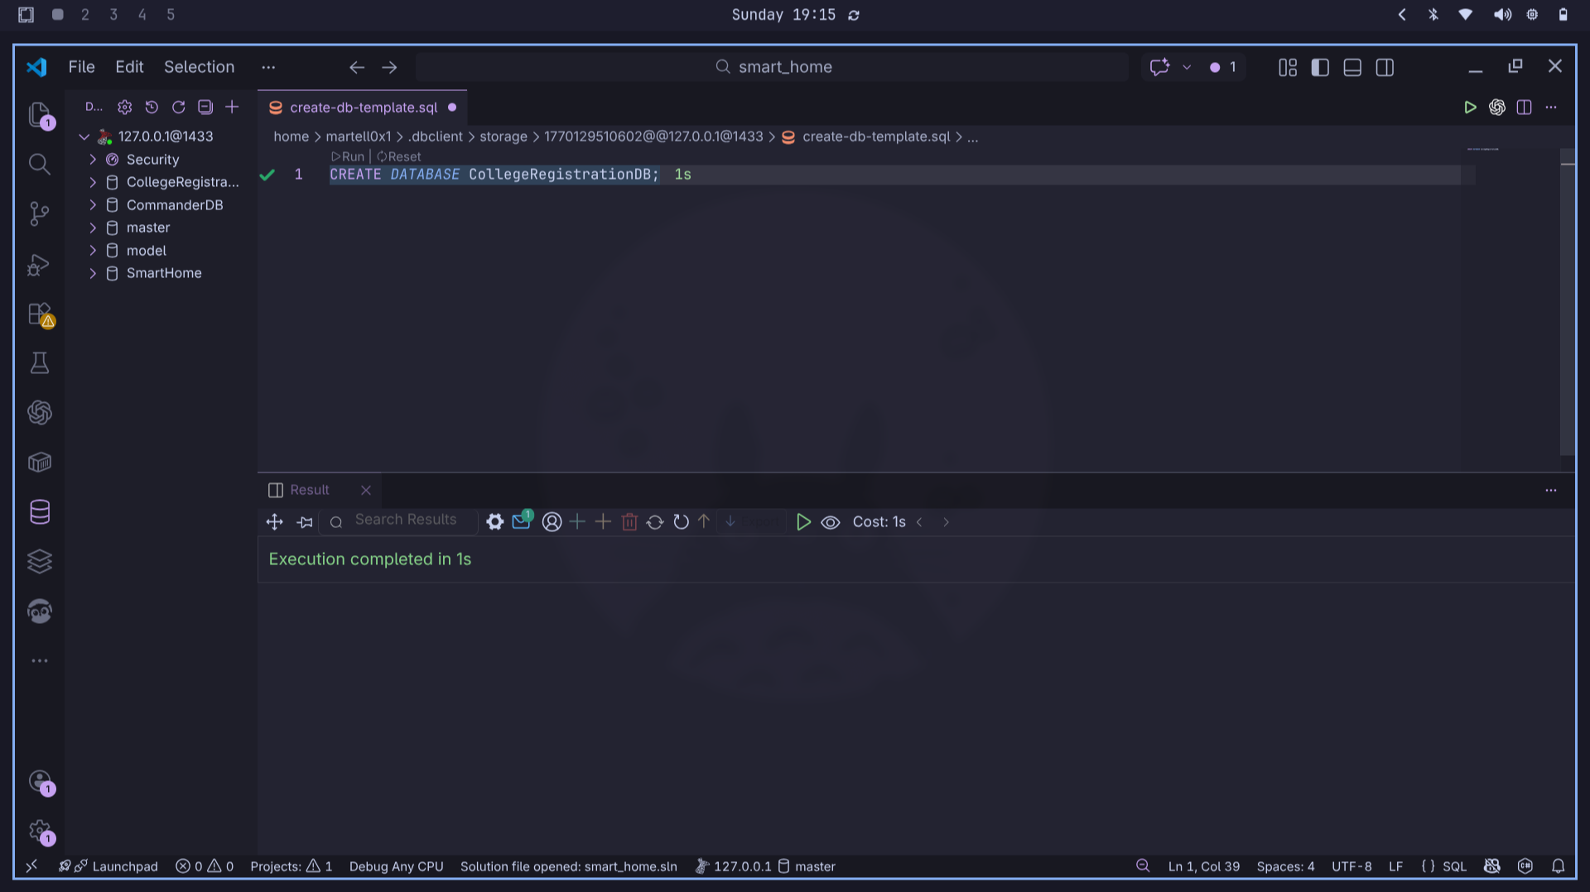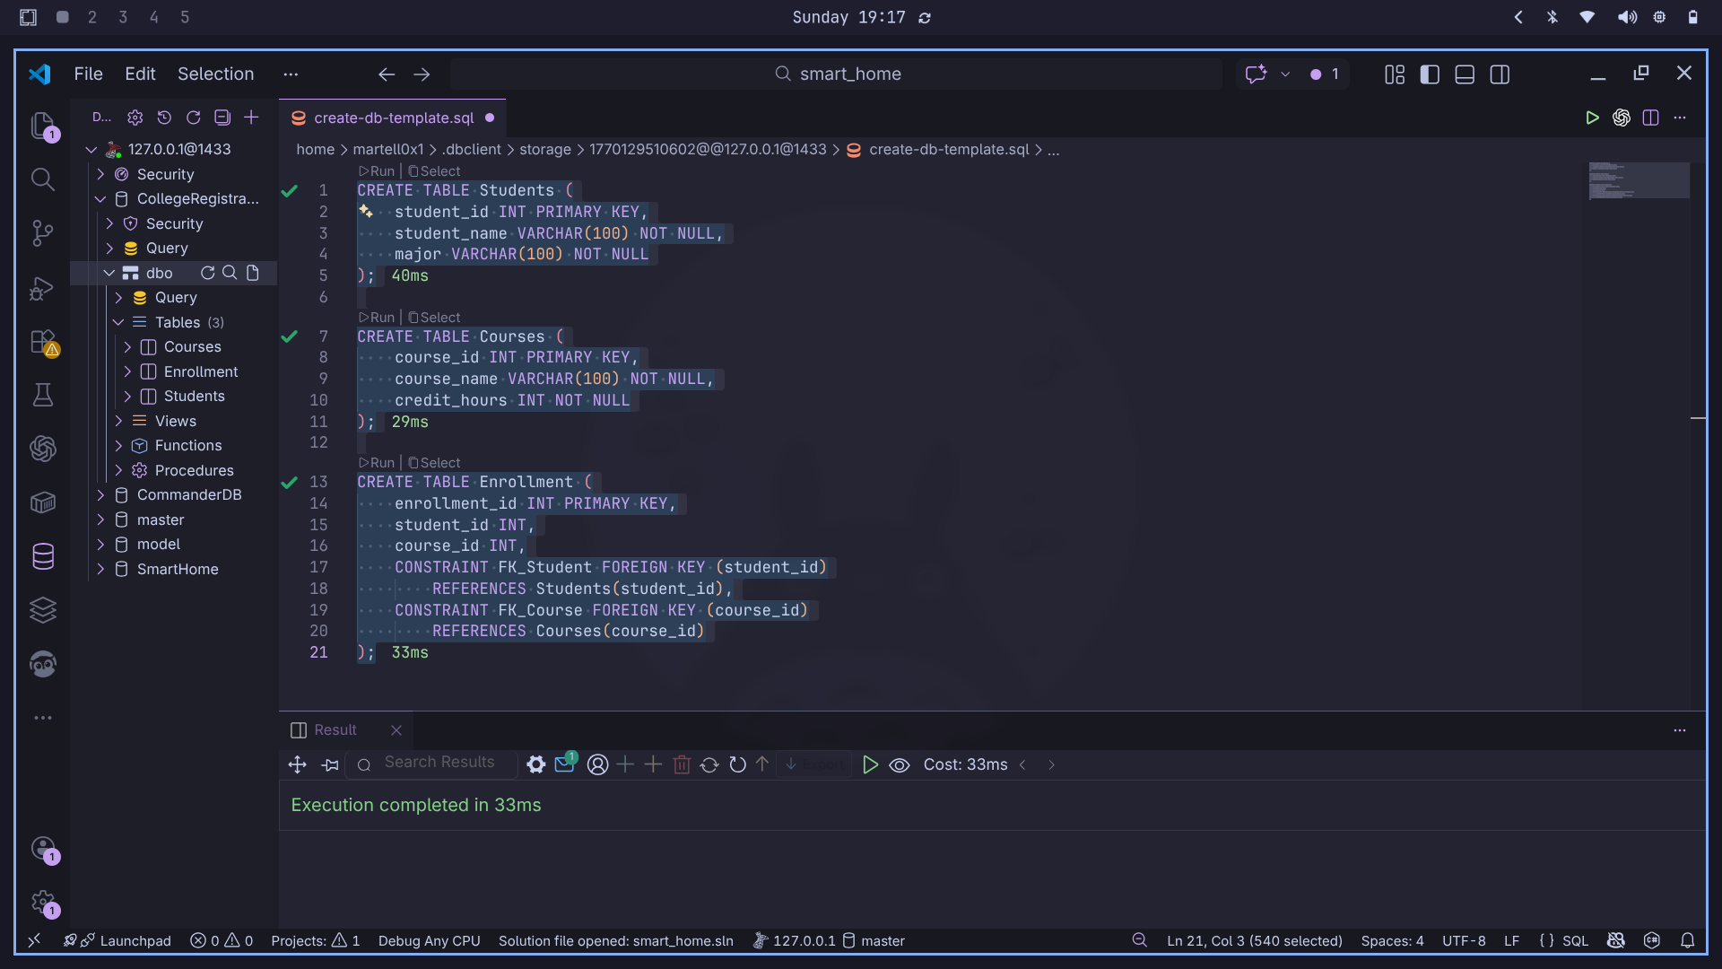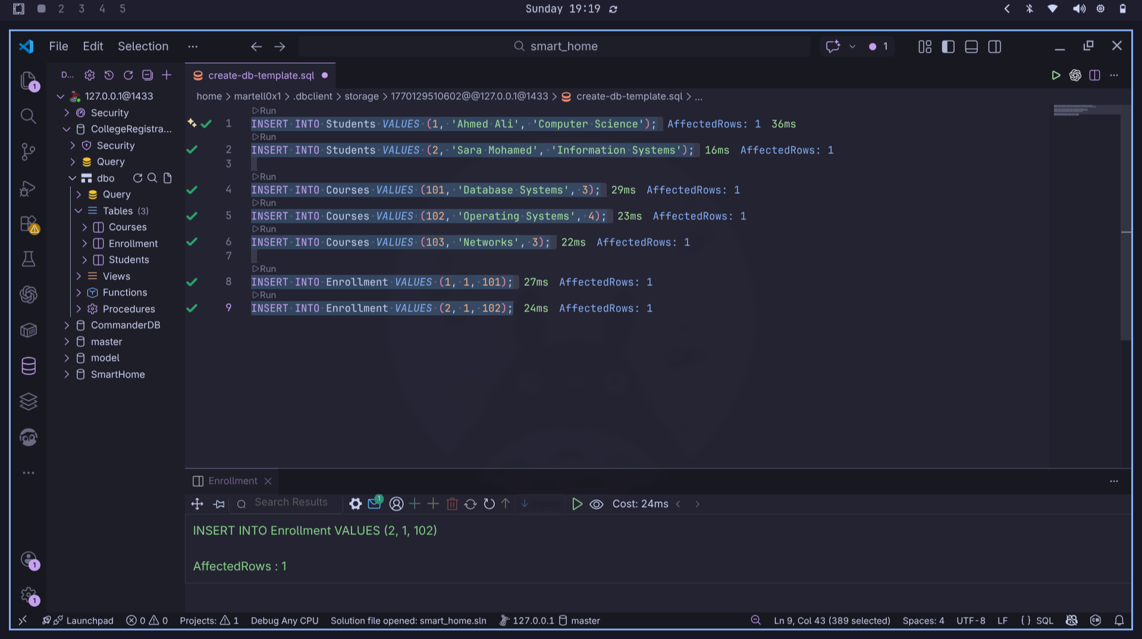
- Viewing Tables after and before Transaction
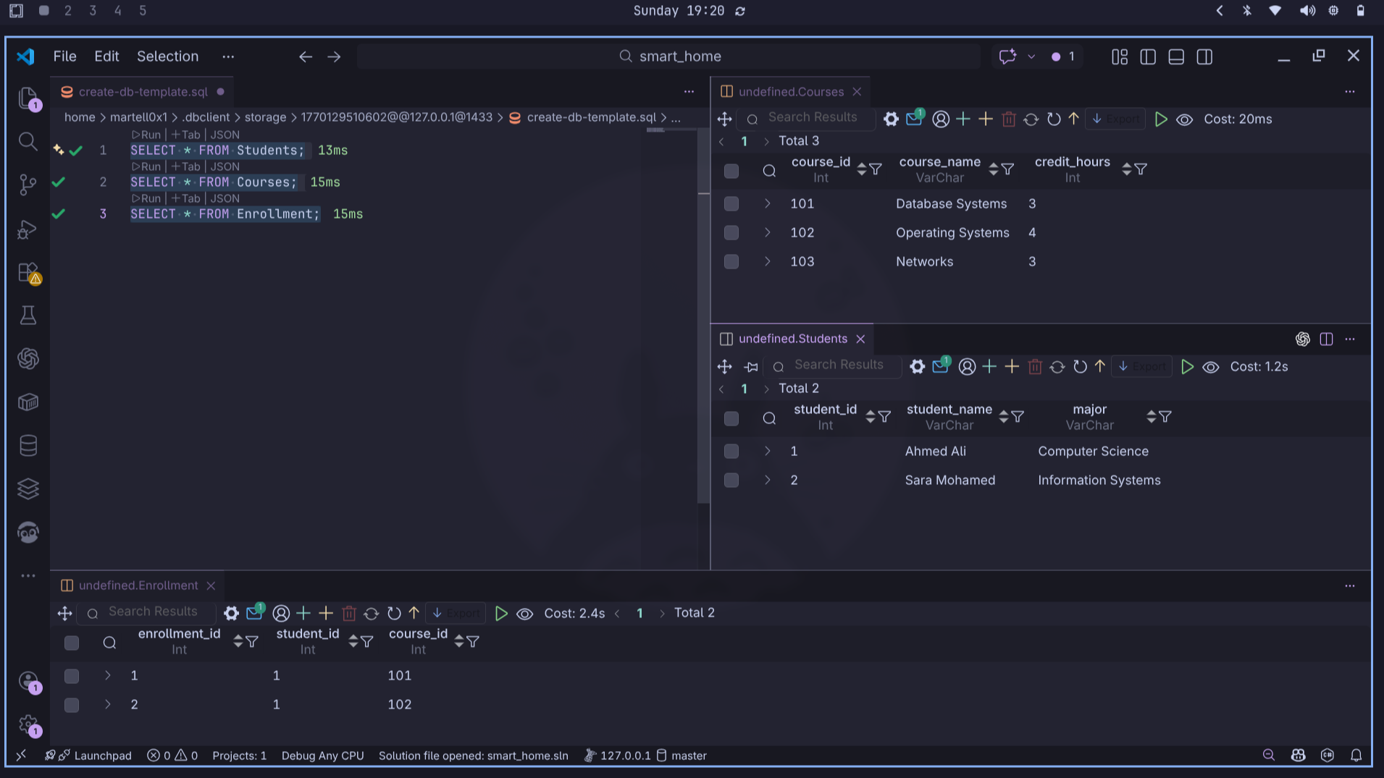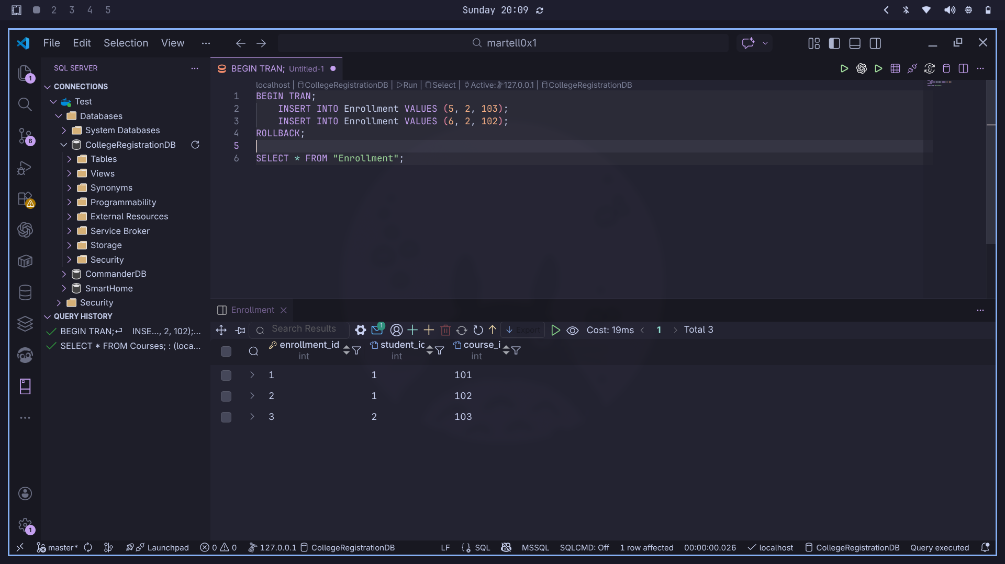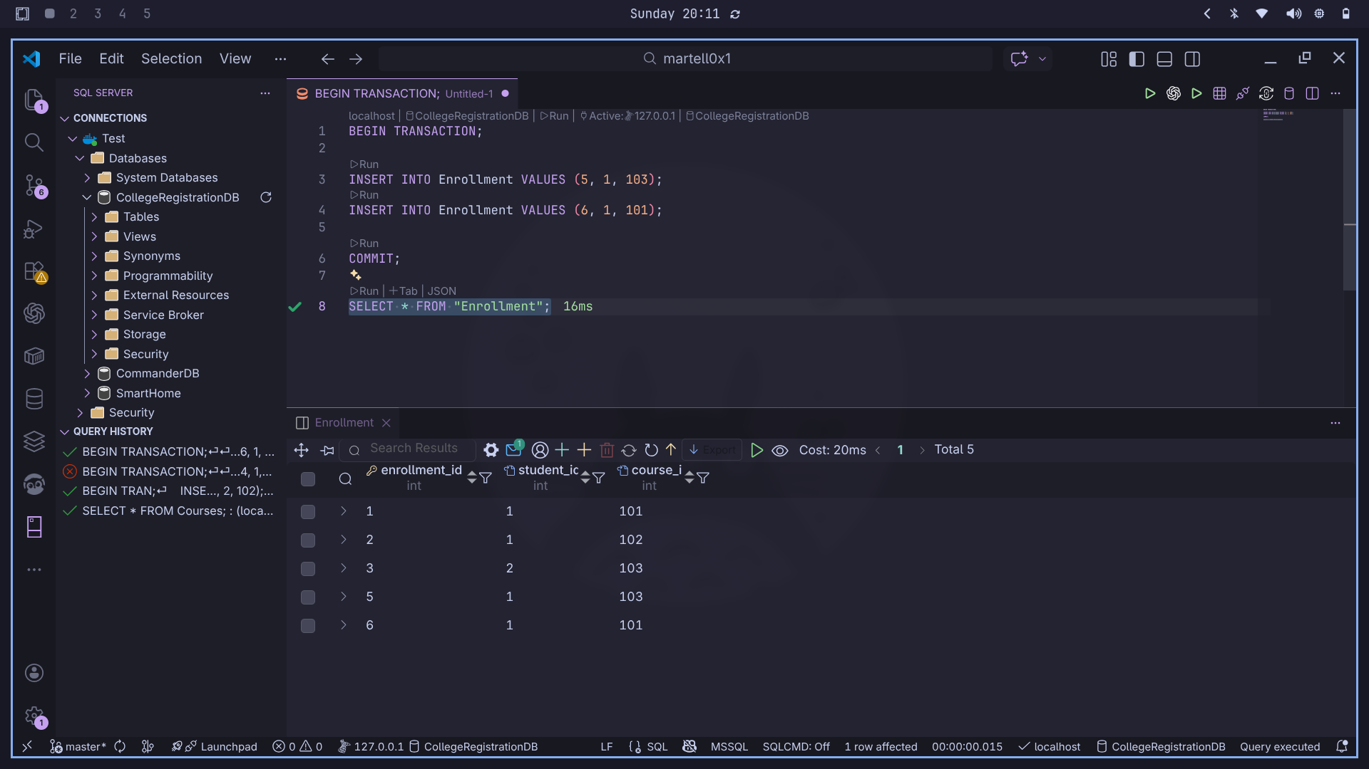
Questions:
1. What is the difference between COMMIT and ROLLBACK?
-> COMMIT saves changes after transaction occures in the DBMS
-> ROLLBACK undo changes and returns the data state into the previous state before transaction

2. What problems could occur if transactions were not used?
-> If transactions aren’t used, data can become inconsistent when only part of an operation succeeds.
Partial updates may cause data loss if a failure occurs mid-operation.
Concurrent operations can lead to race conditions, where simultaneous changes corrupt the data.

3. Which ACID property is demonstrated when using ROLLBACK?
-> Atomicity

